Contents

160540A / Lai Wei Jing, Eugene 3

Enemy Artificial Intelligence 3

Turret [Enemy] 3

Robot [Enemy] 6

Map Editor 7

Debugger 7

Text Manager 8

Conversation Message 8

Battle Message 9

Impact Message 10

Locked-on 11

Scene Manager 12

BGM and SFX 12

Battlefield 12

Gun shot 12

Text display 12

163940Z / Chan Zhihao 13

Camera 13

Pan to target and pause. 13

Pan to multiple location 14

Particles 15

Rain 15

Melee 16

Stab and Slash Combo 16

Menu 17

Main Menu 17

Level Selection 18

Enlarged mini-map 19

161725E / Lim Guan Sheng, Marcus 20

File Manager 20

Write Level 20

Write Enemy 20

Load Level 21

Load Enemy 22

Inventory 23

Equipment 24

Shop 26

Purchase equipment 26

160853T / Kwong Yu Ming 27

Attributes 27

Gamepad 27

Quest Manager 28

Transformation of Objects 28

Walking animation [Robot] 28

Object and TGA 29

# 160540A / Lai Wei Jing, Eugene

## Enemy Artificial Intelligence

### Turret [Enemy]

Health bar shrinks accordingly to health left.

Scale capped at a fixed amount.

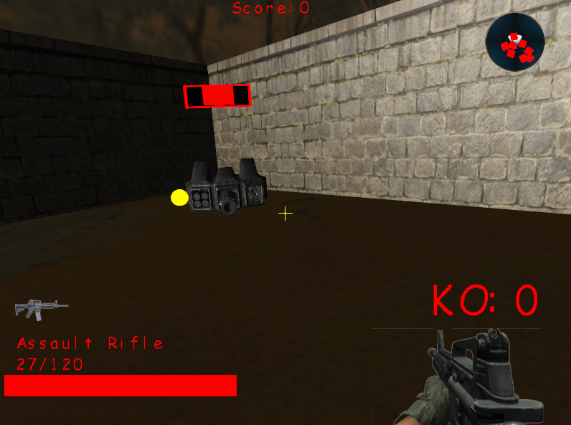

The red outer quad represents the status of the turret. [Ally or Enemy]

When the turret’s status is Enemy, it will be red colour.

The turret will target player and player’s turret.

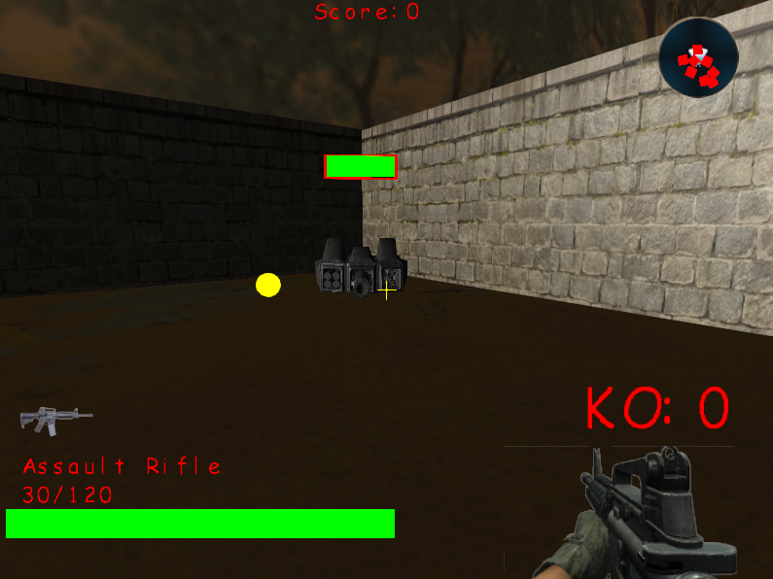

Ally Mode.

The turret targets all enemies.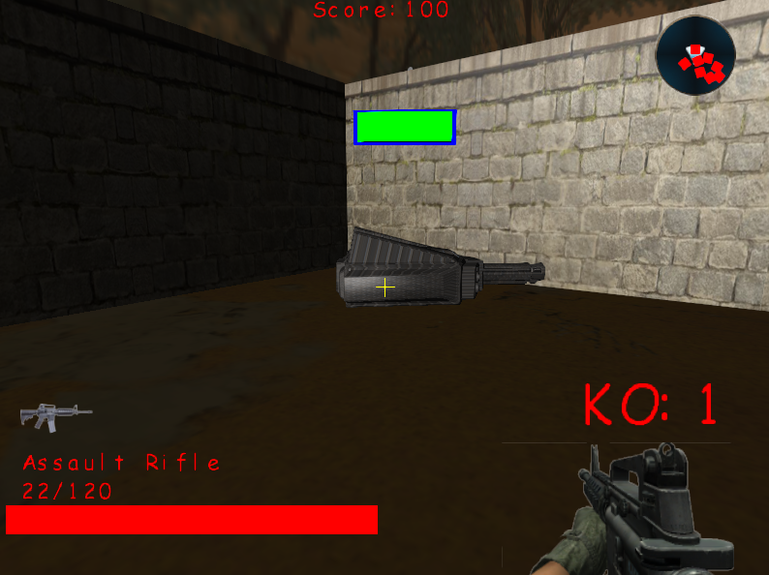

### Robot [Enemy]

Pathfinding logic that prevents the robot from colliding with one another.

Creates a create of nodes around the enemy, if it collides with any other object(s), erase the node. Check the remaining nodes for the shortest distance and move enemy towards that point.

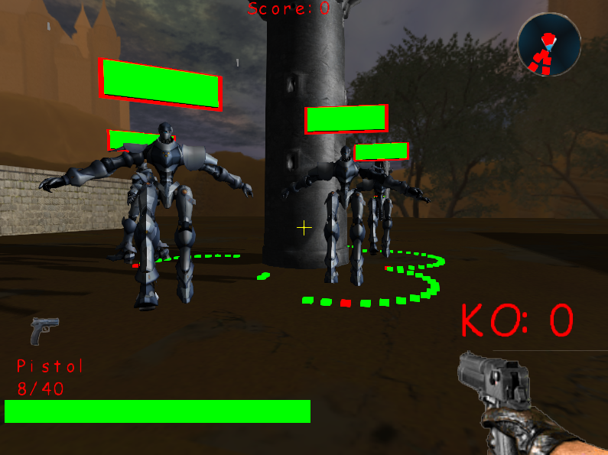

## Map Editor

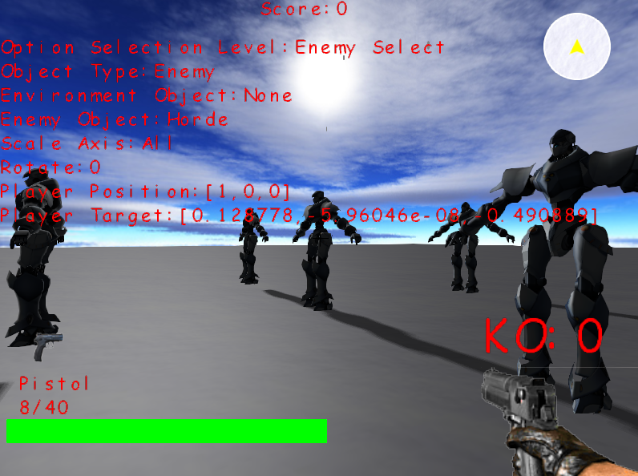

## Debugger

Used to cout messages that we defined only when the Debugger is turned on.

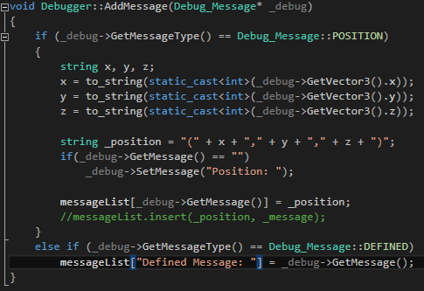

## Text Manager

### Conversation Message

Print the characters one by one.

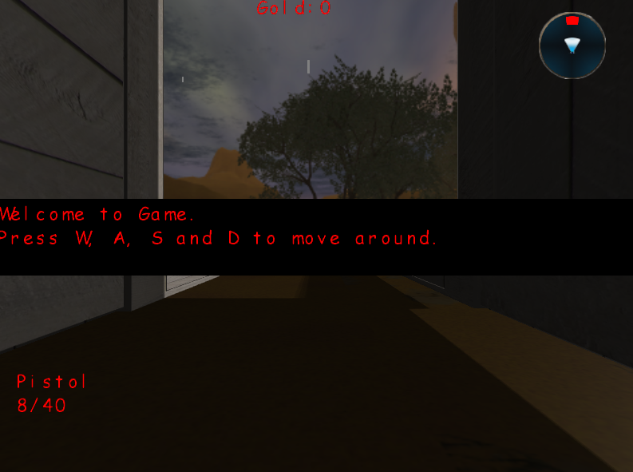

### Battle Message

Displaying level objective and remaining towers.

Message will slowly expand to the entire width of the screen.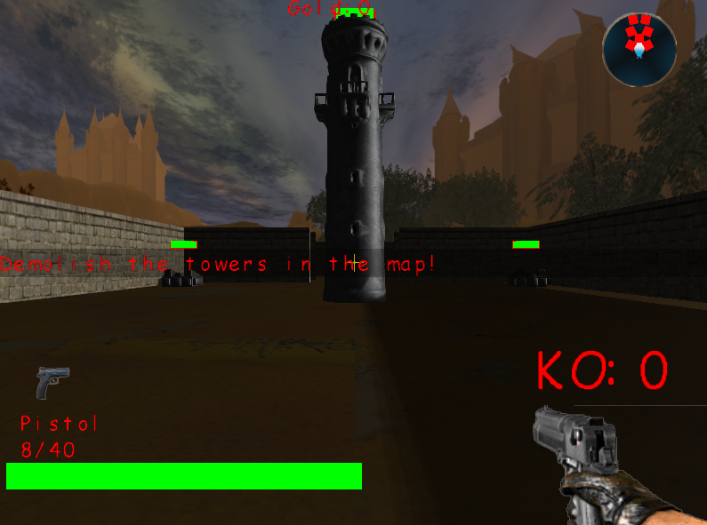

### Impact Message

Printing each key one by one on screen when special enemy appeared.

Character will reduce scale size and increase when it is added to the screen.

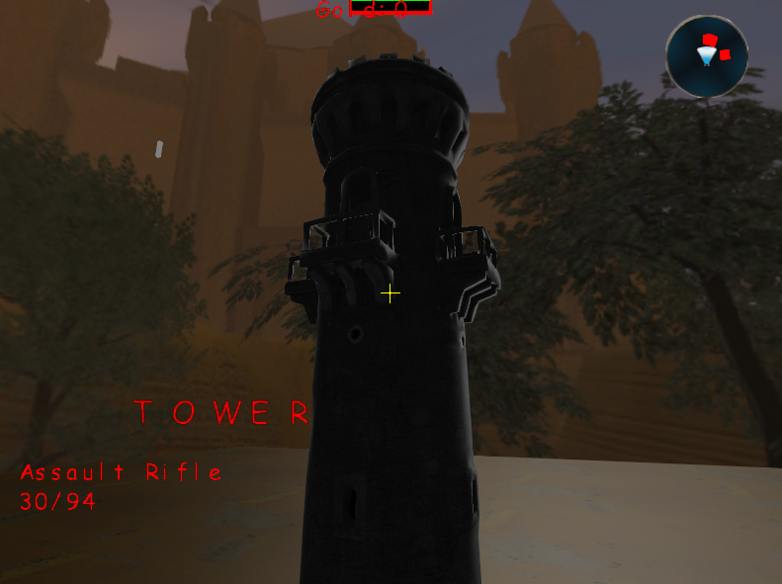

## Locked-on

Press tab will locked-on to the nearest enemy.

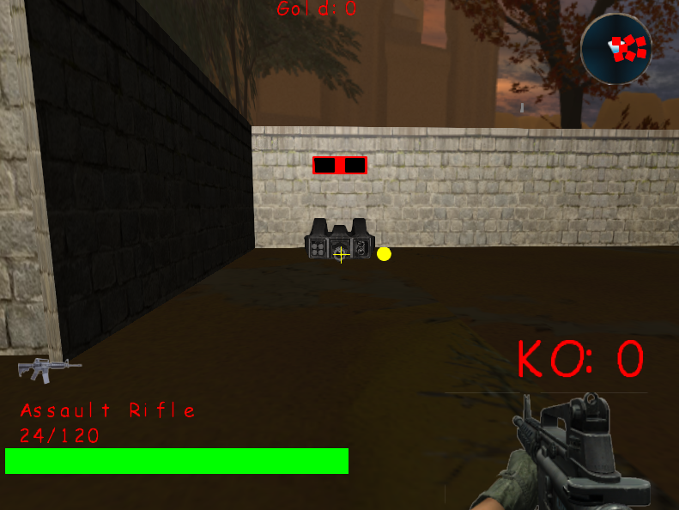

## Scene Manager

Deleting relevant pointers before moving to next scene.

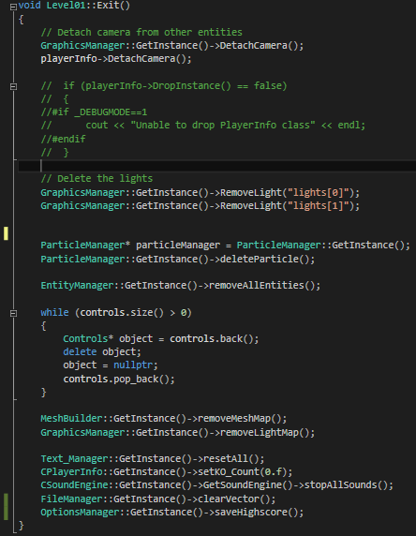

## BGM and SFX

### Battlefield

### Gun shot

### Text display

# 163940Z / Chan Zhihao

## Camera

### Pan to target and pause.

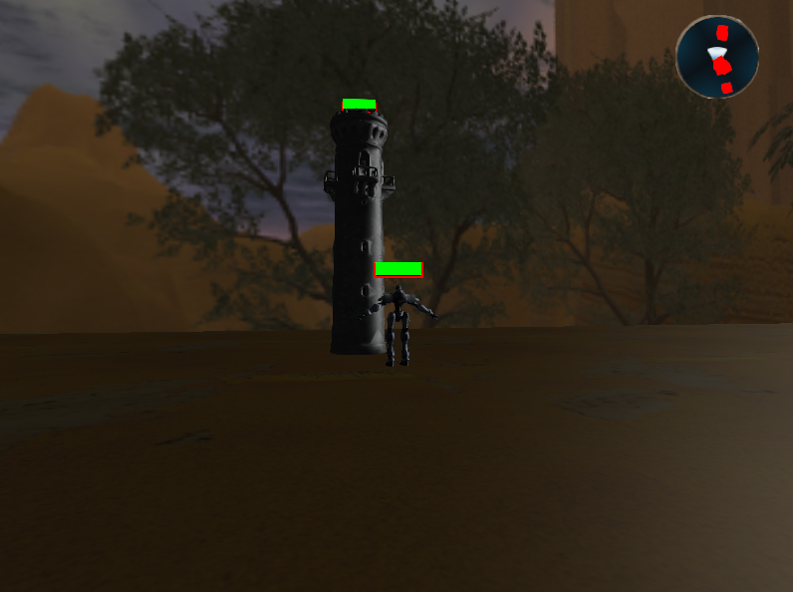

### Pan to multiple location

Move camera from one location to another and continues.

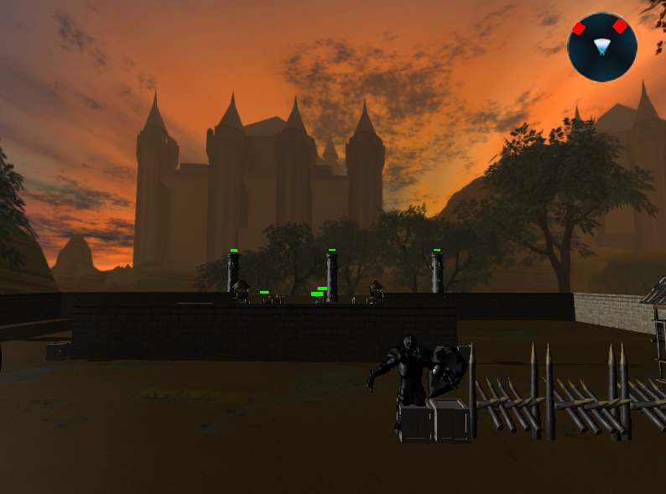

## Particles

### Rain

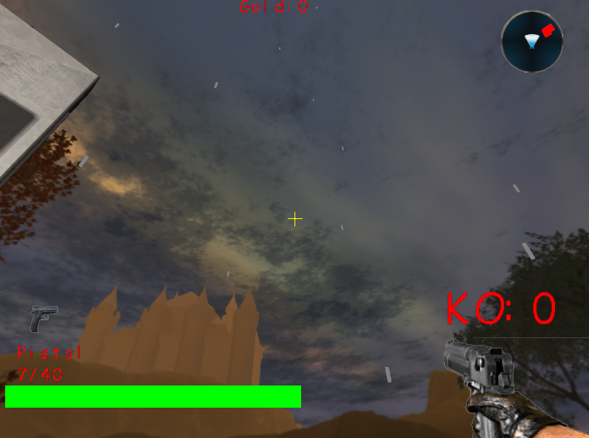

## Melee

### Stab and Slash Combo

Right clicking 4 times in a row will produce a slash on the 5th click.  
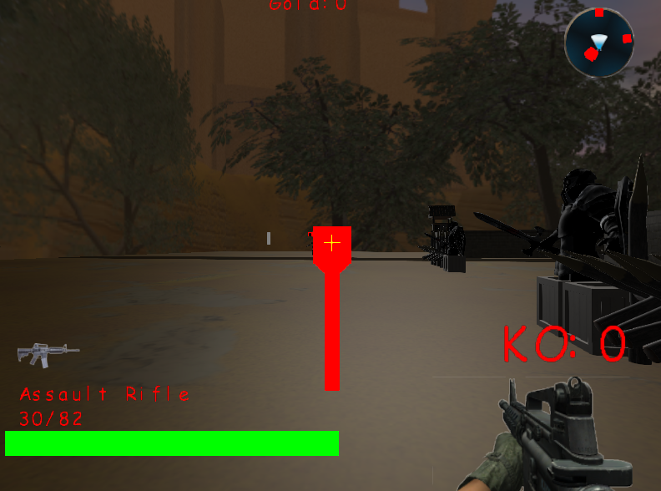

## Menu

### Main Menu

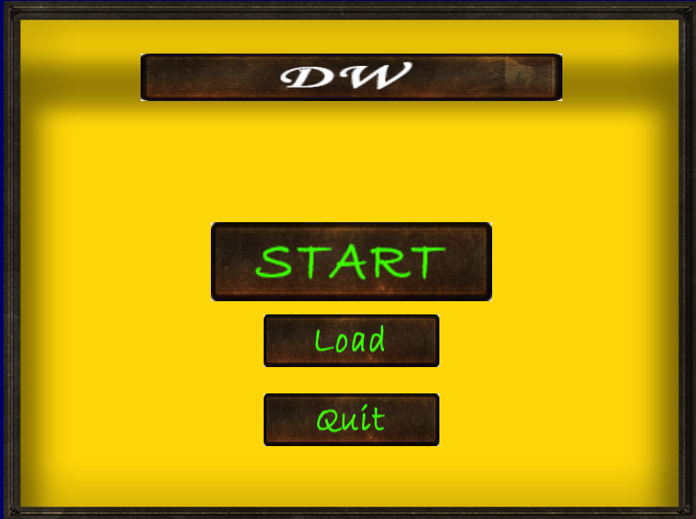

### Level Selection

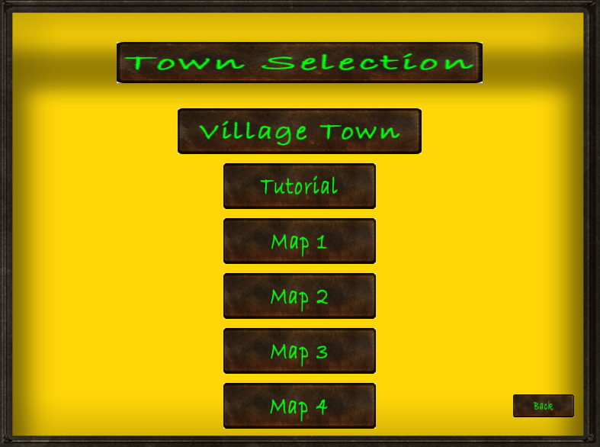

## Enlarged mini-map

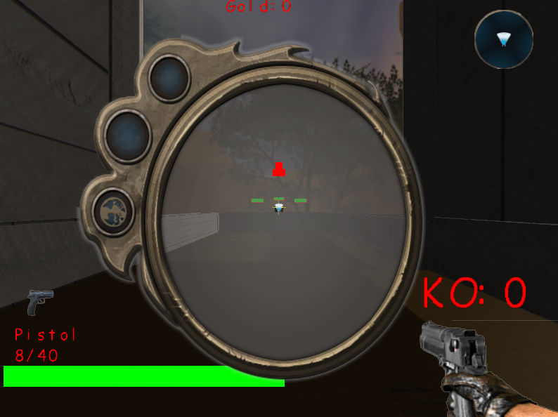

# 161725E / Lim Guan Sheng, Marcus

## File Manager

### Write Level

Writing the objects created using Map Editor to a CSV file.

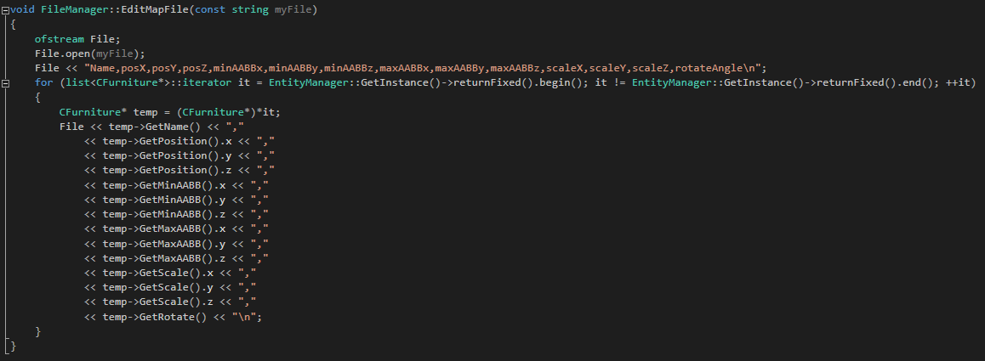

### Write Enemy

Writing the enemies created using Map Editor to a CSV file.

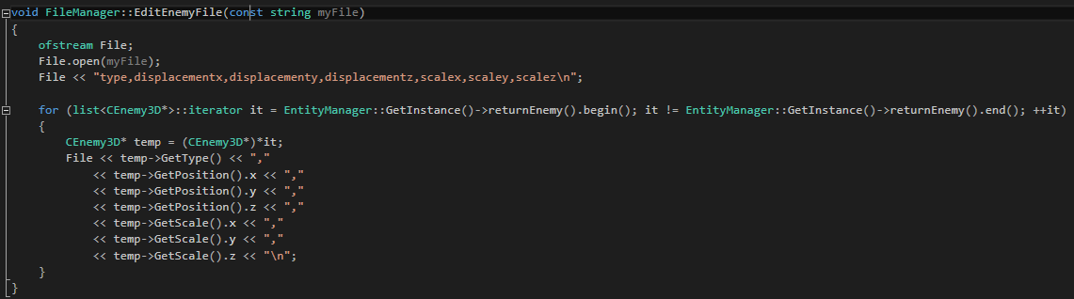

### Load Level

Loading objects from CSV to level.

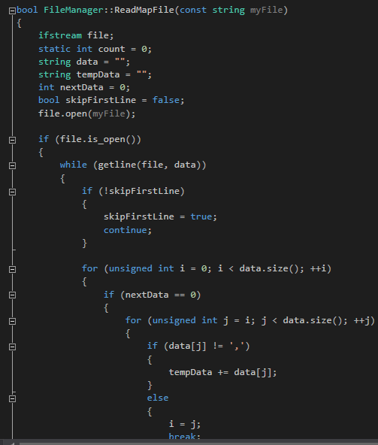

### Load Enemy

Loading enemies from CSV to level.

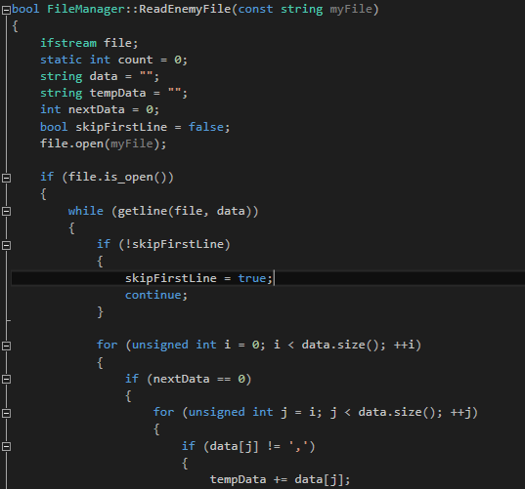

## Inventory

Storing equipment for equipping, unequipping and discarding.

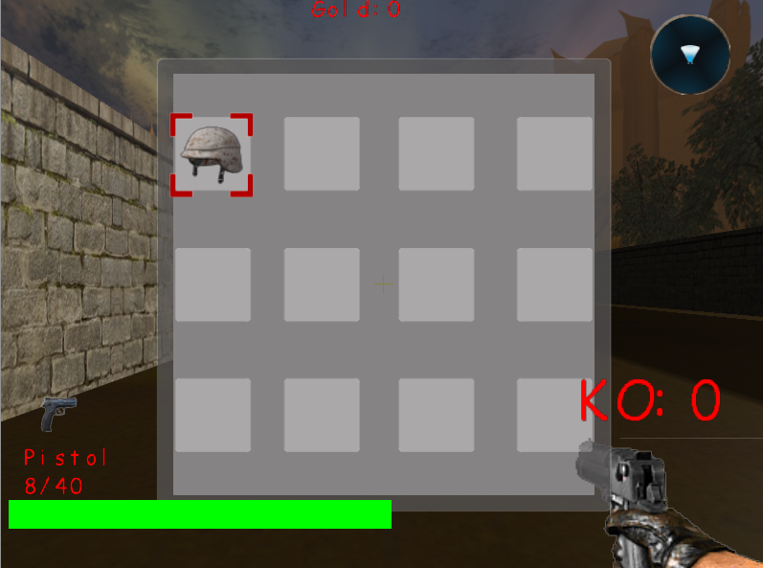

## Equipment

Increase attributes to power up player.

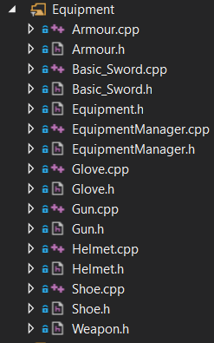

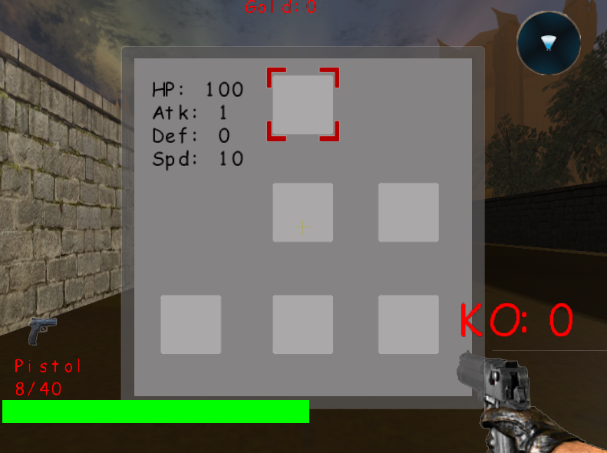

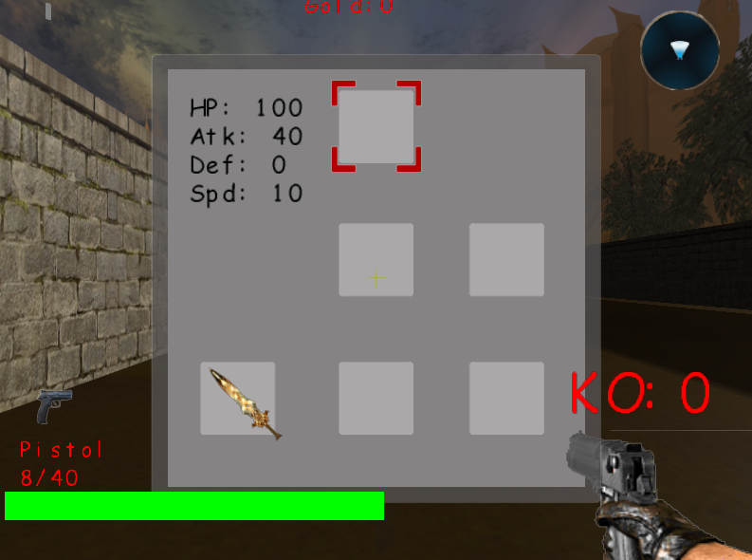

## Shop

### Purchase equipment

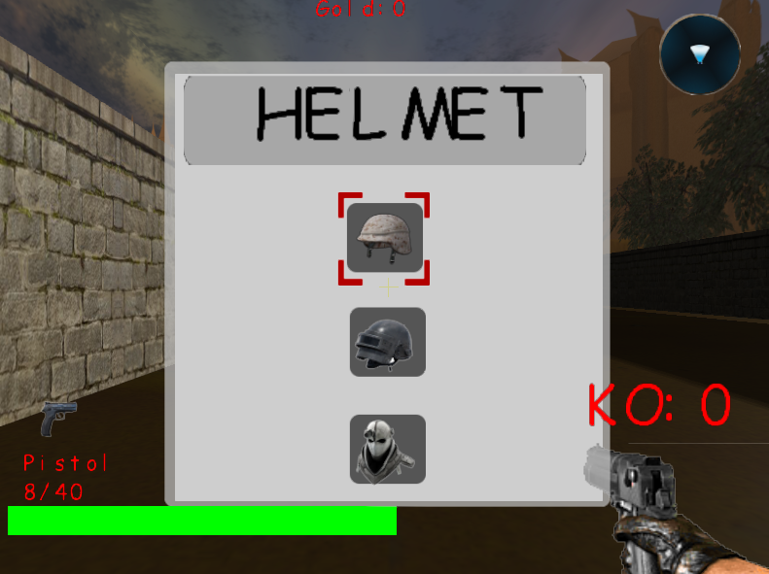

# 160853T / Kwong Yu Ming

## Attributes

Power-up the player and enemy status.

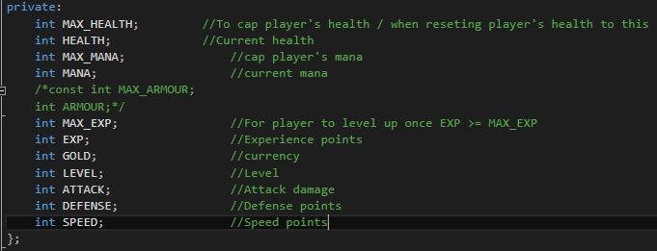

## Gamepad

Play the game using gamepad.

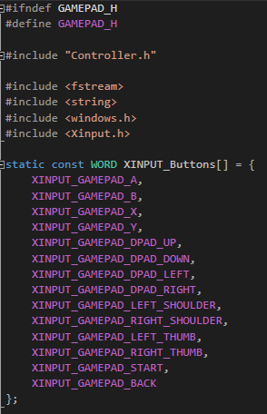

## Quest Manager

Creating quests for player to complete.

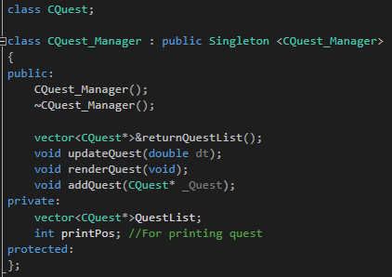

## Transformation of Objects

### Walking animation [Robot]

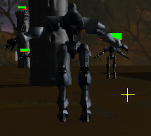

## Object and TGA

Skybox, Tower, Turret, Robot and environmental objects.

